EXPERIMENT NO. 04

TITLE: Unary operator overloading to increment/decrement real number.

EXPECTED DATE OF PERFORMANCE: 26/10/2020

ACTUAL DATE OF PERFORMANCE: 26/10/2020

EXPERIMENT GRADE: _______
EXPERIMENT NUMBER 4
NAME OF THE EXPERIMENT: Unary Operator Overloading to increment/decrement real number.
AIM OF THE EXPERIMENT: Overload functionality of unary operator to increment/decrement real number.
EQUIPMENT /COMPONENT/SOFTWARE:
- Any one of g++, Eclipse, Netbeans, CodeBlock, Microsoft VSCode software installed on PC

THEORY/ALGORITHM:
It is a type of polymorphism in which an operator is overloaded to give user defined meaning to it. Overloaded operator is used to perform operation on user-defined data type. For example '+' operator can be overloaded to perform addition on various data types, like for Integer, String (concatenation) etc.

Syntax:
An operator can be overloaded by using the following syntax:

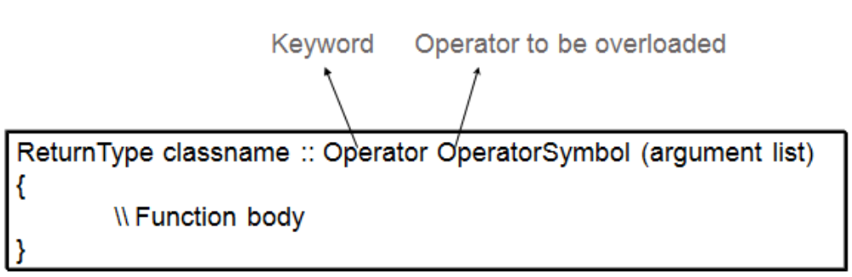

Algorithm

Step 1: Start
Step 2: Create a Class.
Step 3: Declare the variables and its member function.
Step 4: Create following functions as members of class.
showdata(): to show the output of incremented value
Step 5: Create one zero argument constructor and one single argument constructor.
Step 6: Define the function operator ++ to increment the values.
Step 7: Stop

PROCEDURE/PROGRAM:
---------------------------------------------------------------------------------------------------------------------
NOTE: The program given below is incomplete sample program which only gives idea about implementation of logic in programming. Hence direct use of program given below won’t help student to get desired output. Student should use his/her own logic in addition to this program to get desired output. Following this process should enhance student’s programming skills.

class index
{
public:
int count;

index() //zero argument constructor
{
count=0;
}

index(int i) //parameterized constructor
{
count = i;
}

index operator++() //zero argument function to increment count by 1
{
++count;
}

void showdata()
{
cout<<count;
}
};

int main()
{
index c;

cout<<endl<<"c=";
c.showdata();

++c;
cout<<endl<<"c=";
c.showdata();

++c;
cout<<endl<<"c=";
c.showdata();

return 0;
}
---------------------------------------------------------------------------------------------------------------------

RESULT- Sample Input and Output
Output
c=0
c=1
c=2

PROGRAM WRITTEN BY STUDENT:
---------------------------------------------------------------------------------------------------------------------
(Student should copy the program from the IDE and paste the same here.)
//Program
#include<iostream>
#include<iomanip>
using namespace std;
class index
{
public:
int count;

index() //zero argument constructor
{
count=0;
}

index(int i) //parameterized constructor
{
count = i;
}

index operator++() //zero argument function to increment count by 1
{
++count;
}

void showdata()
{
cout<<count;
}
};

int main()
{
index c;

cout<<endl<<"c=";
c.showdata();

++c;
cout<<endl<<"c=";
c.showdata();

++c;
cout<<endl<<"c=";
c.showdata();

return 0;
}

---------------------------------------------------------------------------------------------------------------------

RESULT OBTAINED BY STUDENT:
~~~~~~~~~~~~~~~~~~~~~~~~~~~~~~~~~~~~~~~~~~~~~~~~~~~~~~~~~~~~~~~~~~~~~~~~~~
(Student should copy the program result from the IDE and paste the same here.)
Output
c=0
c=1
c=2

~~~~~~~~~~~~~~~~~~~~~~~~~~~~~~~~~~~~~~~~~~~~~~~~~~~~~~~~~~~~~~~~~~~~~~~

SIMILAR PROGRAMS: (Try the programs given below for practice)
- Write a C++ program to count the number of persons inside a bank, by increasing countwhenever a person enters a bank, using an increment(++) operator overloading function, and decrease the count whenever a person leaves the bank using a decrement(--) operator overloading function inside a class.
- Write a C + + program to implement matrix class. Overload operator ~ to find the transpose of the matrix.
- Implement a C++ program to overload unary minus operator to find the negation of a vector.

REFERENCES:
- Yashwant Kanitkar, “Let Us C++”, 2nd Edition, BPB Publications.
- E Balagursamy, “Object Oriented Programming with C++”, 4th Edition, TMH Publishing Company LTD.
- Bjarne Stroustrup, “The C++ Programming language”, 3rd Edition, Pearson Education.

